For this AWS Machine Learning Dev Day workshop, you will be given access to a CloudLabs platform from Spektra Systems. The Databricks on AWS environment is provided with a running cluster and the pre-loaded notebook.

A Databricks workspace including a cluster and pre-loaded notebook will be provided for each attendant. The workshop url with the activation code will be provided during the workshop. Please refer to this registration [guide](https://spektrasystems.github.io/Databricks-Labs-on-AWS-Registration/databricks/Registration-for-databricks-on-aws-readme.html#registration-process-for-databricks-labs-on-aws) which describe how to launch the environment.

# Using the Databricks Community Edition

The zip file that you have received in your reminder email from Databricks also contains the notebook. You can run the notebook on your own after the workshop by using Databricks Community Edition.

If you do not have a Databricks account, you can get your own free Databricks Community Edition (DBCE) account by going to <http://databricks.com/try-databricks>. Choose “**Community Edition**” (as illustrated in RED on the right).

### Login to your Databricks Community Edition and perform the following steps:

### Launch a [cluster](https://docs.databricks.com/clusters/create.html#create-a-cluster) as described in the Databricks documentation.

### Import the [html](https://pages.databricks.com/rs/094-YMS-629/images/01%20-%20AWS%20ML%20Devdays%20-%20with%20Delta%20MLLib%20and%20MLFlow.html) or [dbc](https://pages.databricks.com/rs/094-YMS-629/images/01%20-%20AWS%20ML%20Devdays%20-%20with%20Delta%20MLLib%20and%20MLFlow..dbc) version of the notebook following the steps outlined below.

# Import a notebook

1. Click the **Workspace** button Workspace Icon or the **Home** button Home Icon in the sidebar. Do one of the following:
   * Next to any folder, click the Menu Dropdown on the right side of the text and select **Import**.
   * In the Workspace or a user folder, click Down Caret and select **Import**.

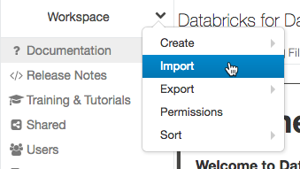

1. Specify the URL (for the html version) or browse (if you’ve downloaded the dbc version) to a file containing a supported external format.
2. Click **Import**.